MACH4METAL

Metalworking machinery
Transito 21,
6909 DA BABBERICH, Netherlands
Tel. + 31 (0)316 – 247123
Fax. + 31 (0)316 - 247956
info@mach4metal.com
www.mach4metal.com

Account No: 66.52.13.883
IBAN : NL33 INGB 0665 2138 83
BIC : INGBNL2A

VIKING Universal CNC 5 Axis tool grinder
- Make : VIKING Denmark
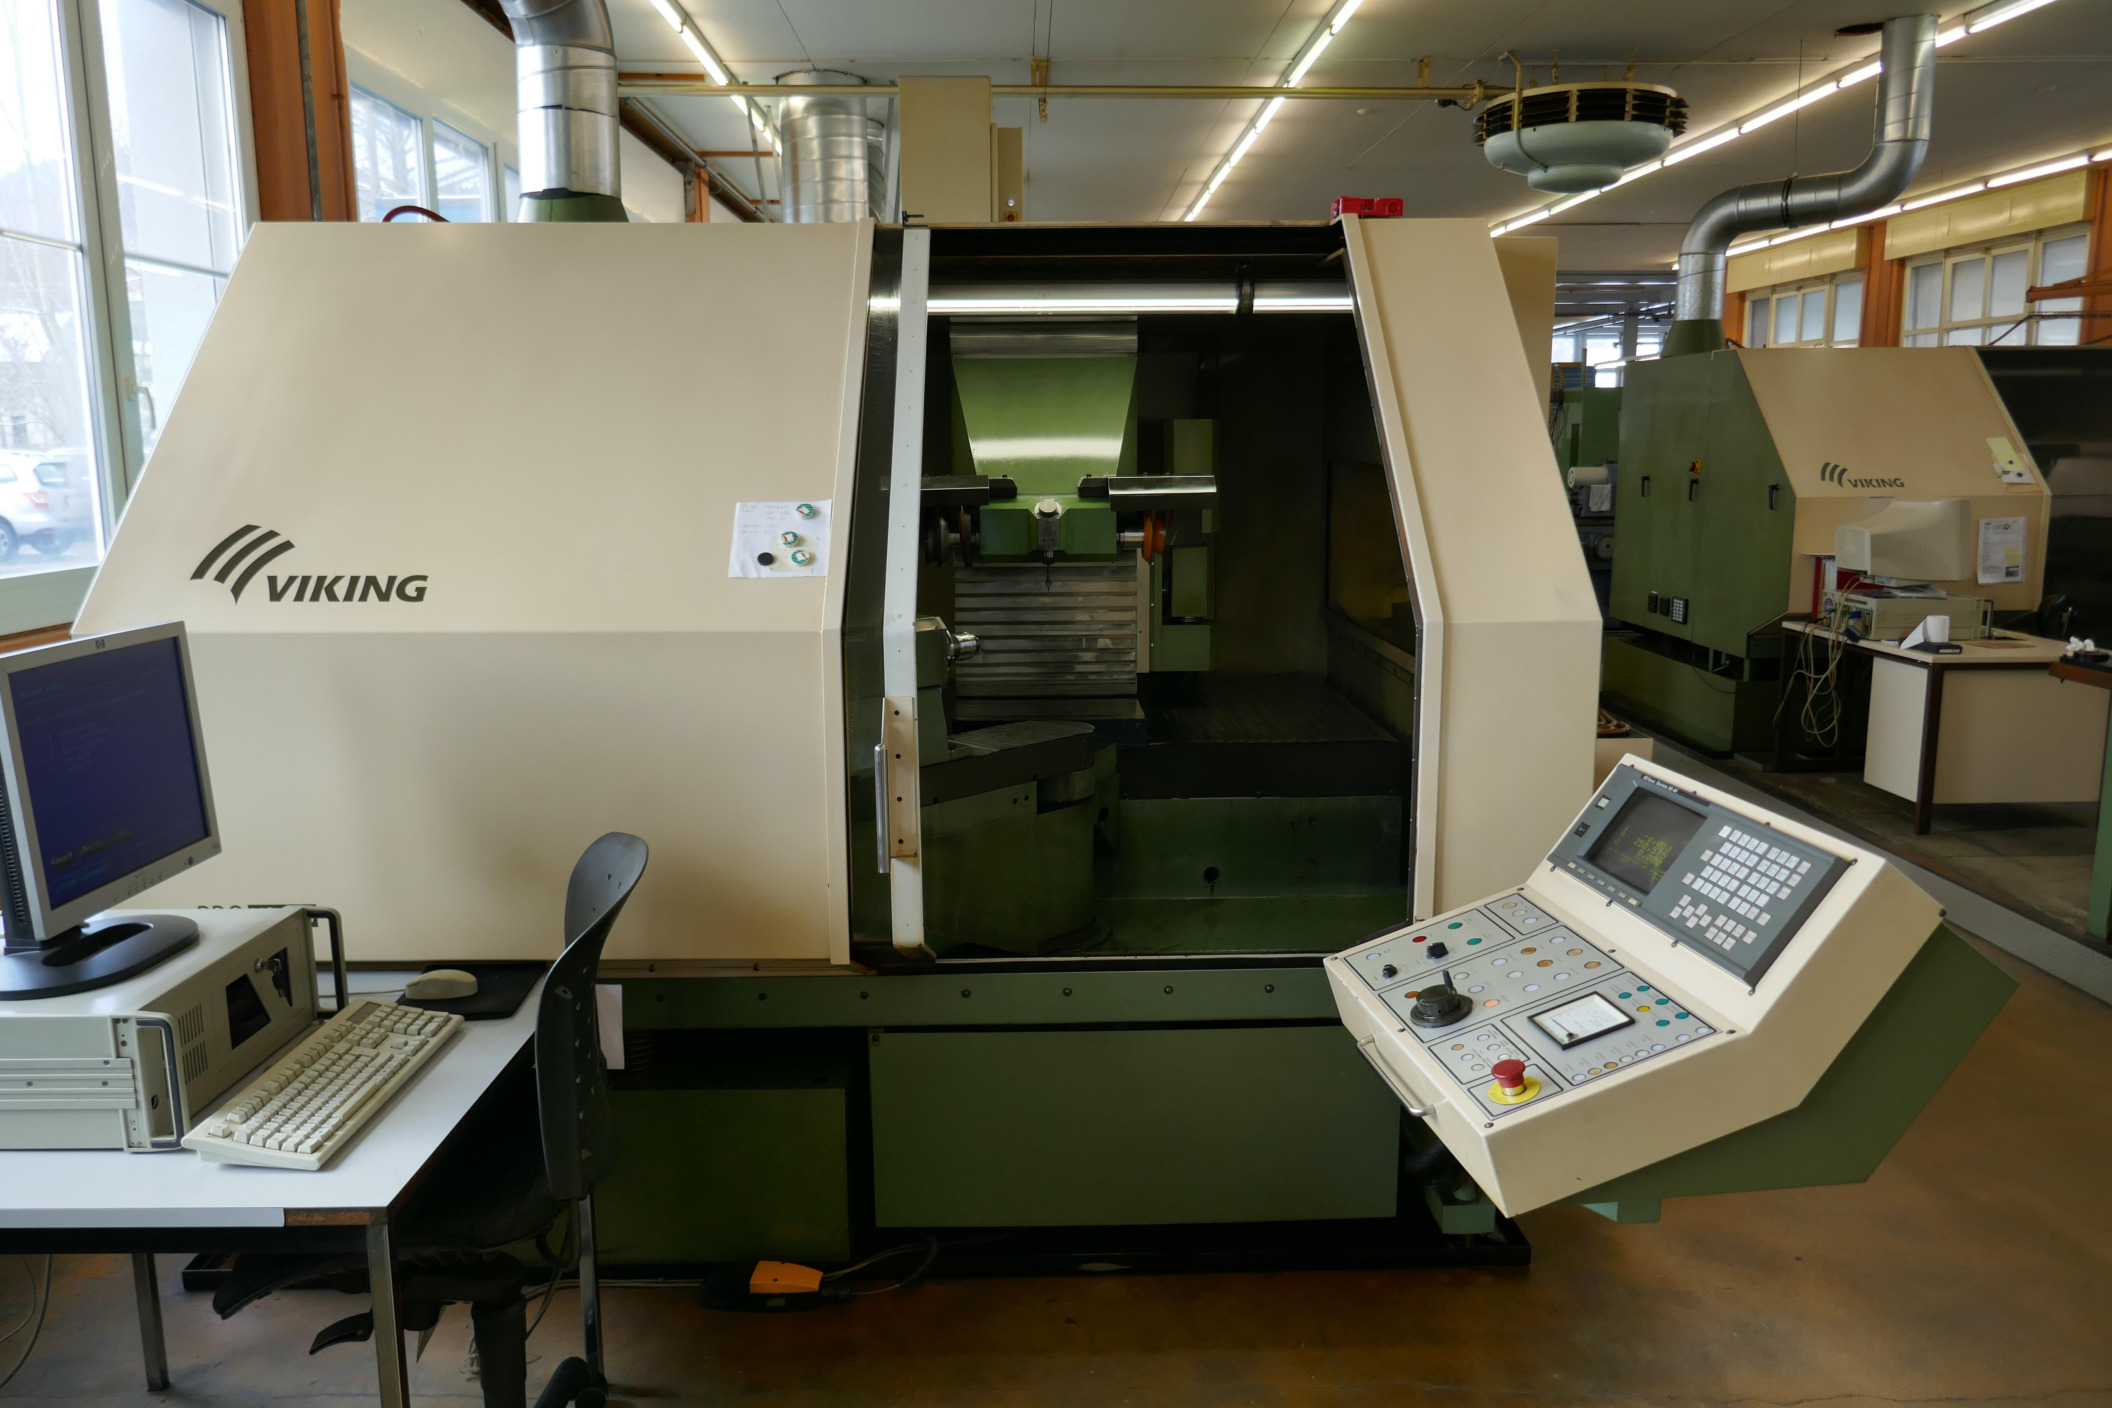
- Type : US – 250 PRO
- Mach. No : 98 9-48
- Age : 1998 – 6.500 H

- X Travel : 850
- Y Travel : 230
- Z Travel : 275
- W Travel : 102°
- U Travel : 255
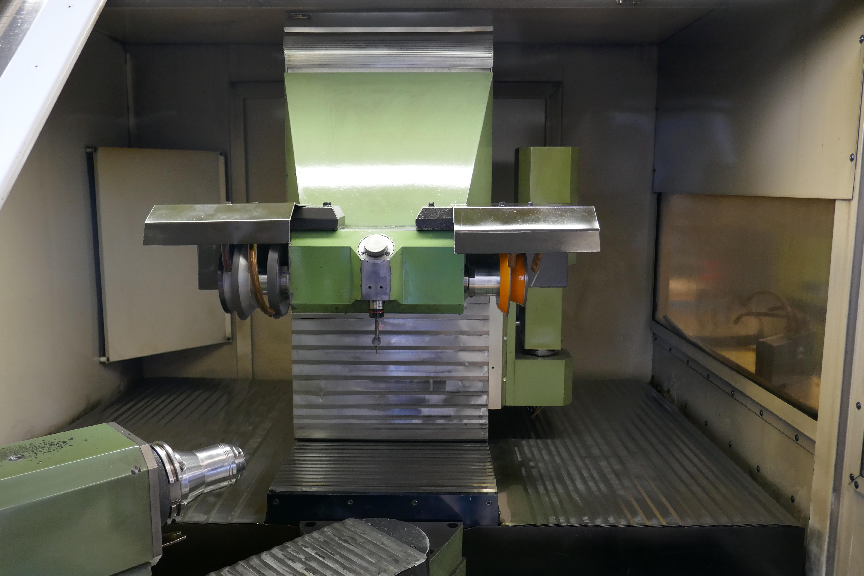
- A Travel : 360°

- Max. work length : 350
- Max. grinding length : 250
- Max. diameter : 280
- Automatic positioning Marposs

- Grinding spindle power : 6.4 kW
- Vario speeds : 8.000
- Spindle diameter : Ø 120
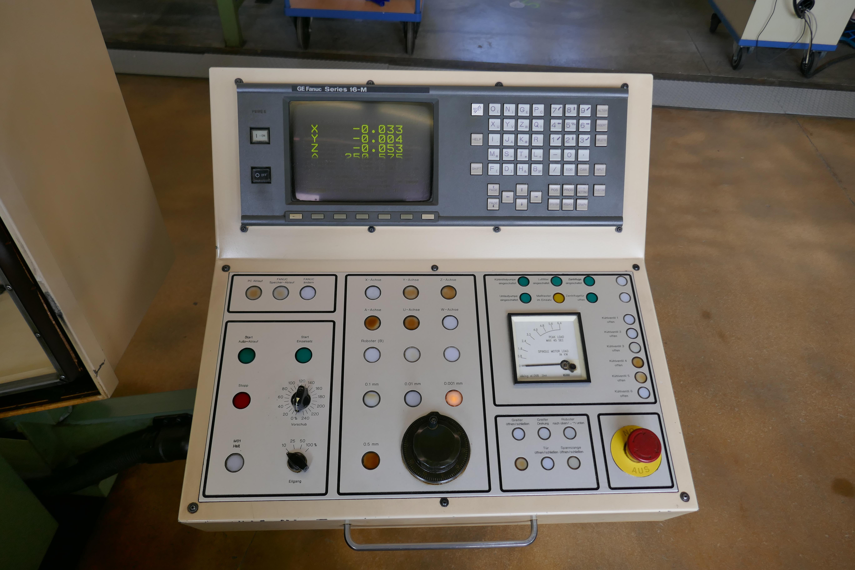
- Spindle 2 x ISO 35

- Spindle taper A Axis : ISO 50
- Locking hydraulic : 60 bar
- Dresser stone : up to Ø 120

- FANUC 16 M in 5 Axis
- Coolant system 1200 L x 16 Bar

- Dimensions
- Length : 2400
- Width : 1980
- Height : 2150
- Weight : 4000

Please Note: The above information has been obtained to the best of our ability and belief from, and from the manufacturers where possible. It is given in good faith, but its accuracy can not be guaranteed. Accordingly, it will not form a representation or constitute contractual terms. We advise you to check any vital details!

